EXP NO – 1.4

**NAME RAJDEEP JAISWAL UID – 20BCS2761**

**BRANCH – B.TECH (CSE) SEC/GROUP – 26(B)**

**SEMESTER – 2ND D.O.P – 3 MAY 2021**

**SUBJECT – COMPUTER WORKSHOP**

**TOPIC**

**"R-r-riddikulus" used in the movie Harry Potter to transform anything from one form to other, Similarly you have to transform the array by rotation.**

**A left rotation operation on an array shifts each of the array's elements 1 unit to the left. For example, if 2 left rotations are performed on array [1,2,3,4,5], then the array would become [3,4,5,1,2].**

**Given an array a of n integers and a number, d, perform d left rotations on the array. Return the updated array to be printed as a single line of space-separated integers.**

**Input Format**

**The first line contains two space-separated integers n and d, the size of a and the number of left rotations you must perform.**

**The second line contains space-separated integers a[i] .**

SOLUTION

*"R-r-riddikulus"* used in the movie Harry Potter to transform anything from one form to other, Similarly you have to transform the array by rotation.

A *left rotation* operation on an array shifts each of the array's elements 1 unit to the left. For example, if 2  left rotations are performed on array [1,2,3,4,5], then the array would become [3,4,5,1,2].

Given an array a of n integers and a number, d, perform d left rotations on the array. Return the updated array to be printed as a single line of space-separated integers.

**Example:**

**Input:** n = 5, d = 4, a = [1, 2 ,3 ,4, 5]

**Output:** 5 1 2 3 4

CODE IN TEXT FORM –

#include <bits/stdc++.h>

using namespace std;

void shiftDNumbers(int n, int d, int a[])

{

int f[d];

    for (int i = 0; i < d; i++)

        f[i] = a[i];

    int l = 0;

    for (int i = d; i < n; i++)

        a[l++] = a[i];

    for (int i = 0; i < d; i++)

        a[l++] = f[i];

    for (int i = 0; i < n; i++)

        cout << a[i] << " ";

    cout << "\n";

}

int main()

{

int n = 5, d = 4;

 d = d % n;

    int a[n] = {1, 2, 3, 4, 5};

shiftDNumbers(n, d, a);

    return 0;}

**CODE IN COMPILER/IDE-**

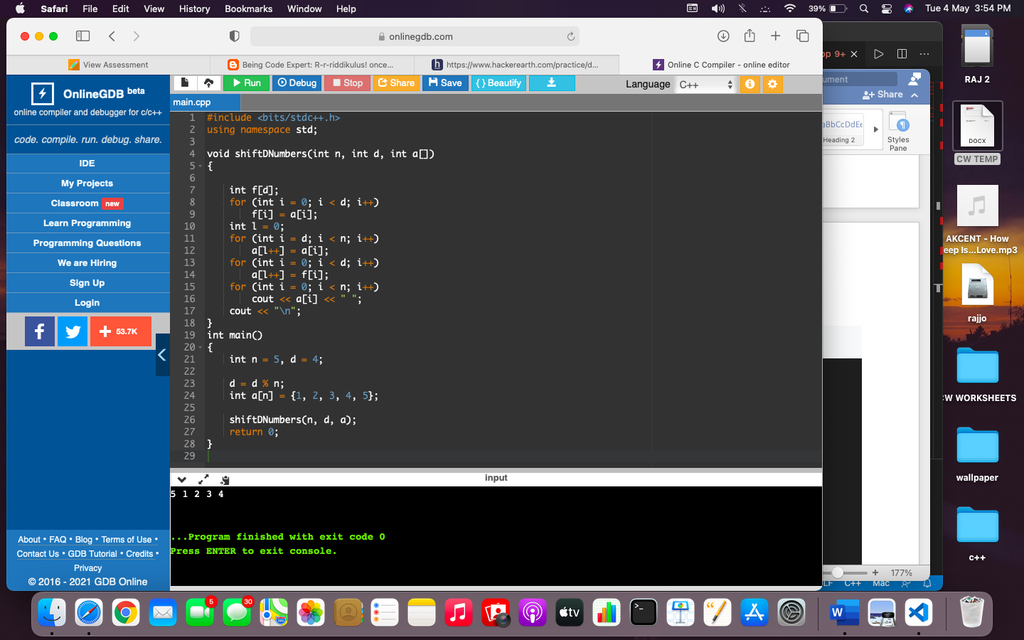

**OUTPUT-**

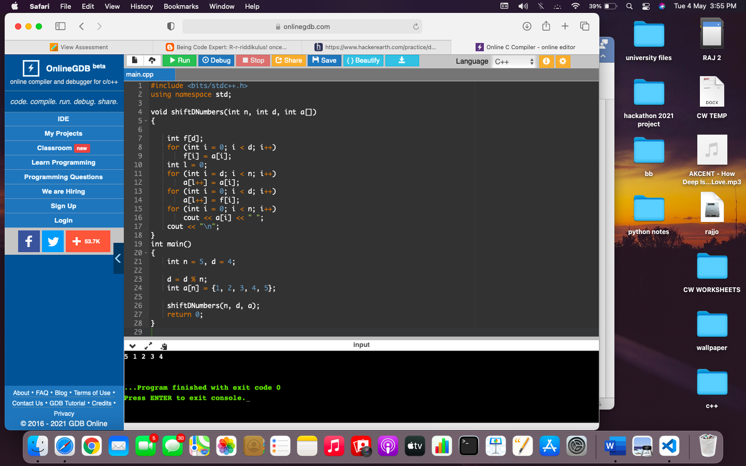-

LEARNING OUTCOMES

1. Apply coding skills to solve application based problems on competitive platforms such as Hacker Rank/ Hacker Earth/Code Chef.
2. Understand the basic concept and structure of computer hardware
3. Identify the existing configuration of the computers and peripherals.
4. Installing and uninstalling multiple operating systems on a machine.
5. Apply their knowledge about computer peripherals to identify /rectify problems on-board.

EVALUATION COLUMN (To be filled by concerned faculty only)

|  |  |  |  |
| --- | --- | --- | --- |
| **Sr. No.** | **Parameters** | **Maximum**  **Marks** | **Marks**  **Obtained** |
| 1. | Worksheet Completion including writing learning objective/ Outcome | 10 |  |
| 2. | Post Lab Quiz Result | 5 |  |
| 3. | Student engagement in Simulation/ Performance/ Pre Lab Questions | 5 |  |
| 4. | Total Marks | 20 |  |